**Bottom Navigation with Navigation Icon from Local Directory**

## Project File Structure

To start with this Example you need to create

1. A directory named pages in your project and create four files DetailsScreen.js, HomeScreen.js, ProfileScreen.js and SettingScreen.js in it.
2. A directory named asset which will have our icons stored.

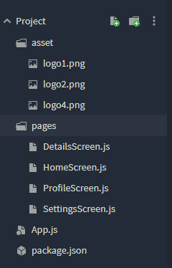   

### Home Tab Setting Tab DetailScreen ProfileScreen

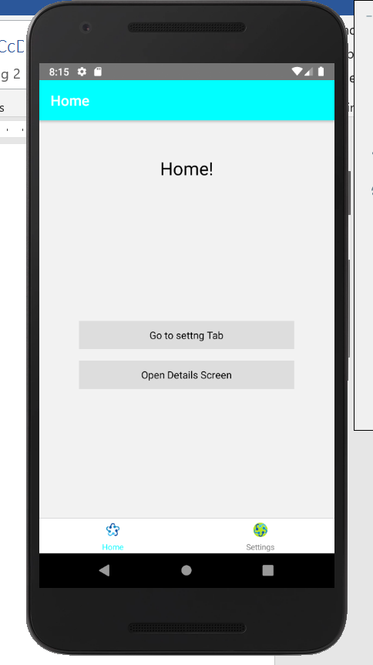 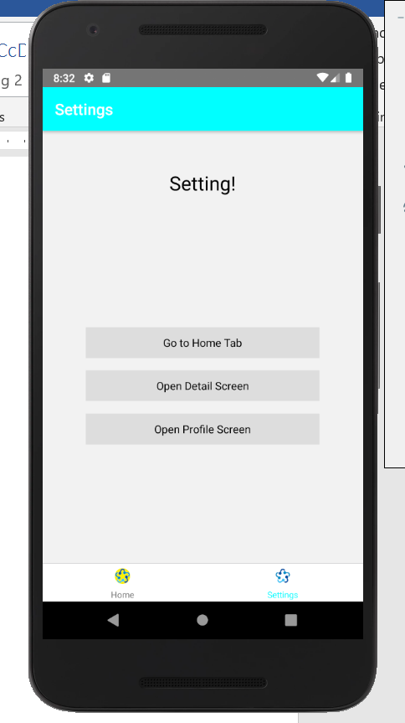 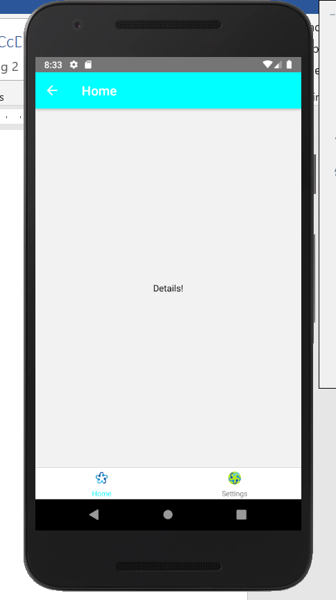 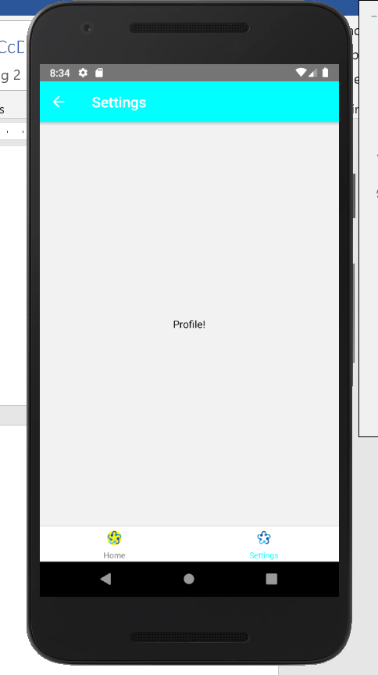

### **App.js**

//This is an example code for Bottom Navigation//

//Icons Used in this example is from local directory//

import React from 'react';

import { Button, Image } from 'react-native';

//Import React Navigation

import { createAppContainer } from 'react-navigation';

import { createBottomTabNavigator } from 'react-navigation-tabs';

import { createStackNavigator } from 'react-navigation-stack';

import HomeScreen from './pages/HomeScreen';

import SettingsScreen from './pages/SettingsScreen';

import DetailsScreen from './pages/DetailsScreen';

import ProfileScreen from './pages/ProfileScreen';

const HomeStack = createStackNavigator(

{

//Defination of Navigaton from home screen

Home: { screen: HomeScreen },

Details: { screen: DetailsScreen },

},

{

defaultNavigationOptions: {

//Header customization of the perticular Screen

headerStyle: {

backgroundColor: '#42f44b',

},

headerTintColor: '#FFFFFF',

title: 'Home',

//Header title

},

}

);

//Defination of Navigaton from setting screen

const SettingsStack = createStackNavigator(

{

Settings: { screen: SettingsScreen },

Details: { screen: DetailsScreen },

Profile: { screen: ProfileScreen },

},

{

//Header customization of the perticular Screen

defaultNavigationOptions: {

headerStyle: {

backgroundColor: '#42f44b',

},

//Header title

headerTintColor: '#FFFFFF',

title: 'Settings',

},

}

);

//Defination of Navigaton bottom options

const App = createBottomTabNavigator(

{

Home: { screen: HomeStack },

Settings: { screen: SettingsStack },

},

{

defaultNavigationOptions: ({ navigation }) => ({

tabBarIcon: ({ focused }) => {

const { routeName } = navigation.state;

if (routeName === 'Home') {

return (

<Image

source={

focused

? require('./asset/logo1.png')

: require('./asset/logo2.png')

}

style={{

width: 20,

height: 20,

borderRadius: 40 / 2,

}}

/>

);

} else if (routeName === 'Settings') {

return (

<Image

source={

focused

? require('./asset/logo1.png')

: require('./asset/logo4.png')

}

style={{

width: 20,

height: 20,

borderRadius: 40 / 2,

}}

/>

);

}

},

}),

tabBarOptions: {

activeTintColor: '#42f44b',

inactiveTintColor: 'gray',

},

}

);

export default createAppContainer(App);

**HomeScreen.js**

//This is an example code for Bottom Navigation//

import React from 'react';

import { Text, View, TouchableOpacity, StyleSheet } from 'react-native';

//Home Screen to show in Home Option

export default class HomeScreen extends React.Component {

render() {

return (

<View style={{ flex: 1, justifyContent: 'center', alignItems: 'center' }}>

<Text style={{ marginTop: 50, fontSize: 25 }}>Home!</Text>

<View

style={{ flex: 1, justifyContent: 'center', alignItems: 'center' }}>

<TouchableOpacity

style={styles.button}

onPress={() => this.props.navigation.navigate('Settings')}>

<Text>Go to settng Tab</Text>

</TouchableOpacity>

<TouchableOpacity

style={styles.button}

onPress={() => this.props.navigation.navigate('Details')}>

<Text>Open Details Screen</Text>

</TouchableOpacity>

</View>

</View>

);

}

}

const styles = StyleSheet.create({

button: {

alignItems: 'center',

backgroundColor: '#DDDDDD',

padding: 10,

width: 300,

marginTop: 16,

},

});

**DetailsScreen.js**

//This is an example code for Bottom Navigation//

import React from 'react';

import { Text, View, TouchableOpacity, StyleSheet } from 'react-native';

//Detail Screen to show from any Open detail button

export default class DetailsScreen extends React.Component {

render() {

return (

<View style={{ flex: 1, justifyContent: 'center', alignItems: 'center' }}>

<Text>Details!</Text>

</View>

); }

}

**ProfileScreen.js**

//This is an example code for Bottom Navigation//

import React from 'react';

import { Text, View, TouchableOpacity, StyleSheet } from 'react-native';

//Profile Screen to show from Open profile button

export default class ProfileScreen extends React.Component {

render() {

return (

<View style={{ flex: 1, justifyContent: 'center', alignItems: 'center' }}>

<Text>Profile!</Text>

</View>

);}

}

**SettingScreen.js**

//This is an example code for Bottom Navigation//

import React from 'react';

import { Text, View, TouchableOpacity, StyleSheet } from 'react-native';

//Setting Screen to show in Setting Option

export default class SettingScreen extends React.Component {

render() {

return (

<View style={{ flex: 1, justifyContent: 'center', alignItems: 'center' }}>

<Text style={{ marginTop: 50, fontSize: 25 }}>Setting!</Text>

<View

style={{ flex: 1, justifyContent: 'center', alignItems: 'center' }}>

<TouchableOpacity

style={styles.button}

onPress={() => this.props.navigation.navigate('Home')}>

<Text>Go to Home Tab</Text>

</TouchableOpacity>

<TouchableOpacity

style={styles.button}

onPress={() => this.props.navigation.navigate('Details')}>

<Text>Open Detail Screen</Text>

</TouchableOpacity>

<TouchableOpacity

style={styles.button}

onPress={() => this.props.navigation.navigate('Profile')}>

<Text>Open Profile Screen</Text>

</TouchableOpacity>

</View>

</View>

);

}

}

const styles = StyleSheet.create({

button: {

alignItems: 'center',

backgroundColor: '#DDDDDD',

padding: 10,

width: 300,

marginTop: 16,

},

});